Post Date

This document records information I have been researching for the project to record the post date.

Header

Line

Mining

Design

## Header

The order header has a field that might be useful.

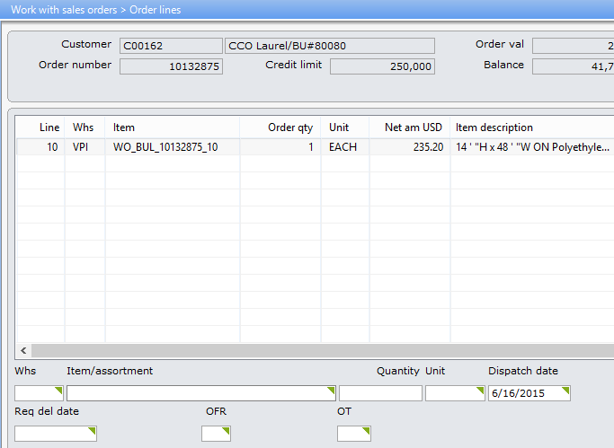

**Dsp dt**

This is the date when the goods will be dispatched to your customer. **Note**: This column/field/function key can only be viewed if you press the **F1** toggle key.

## Line

The line has the following date fields that could be used to record the post date.

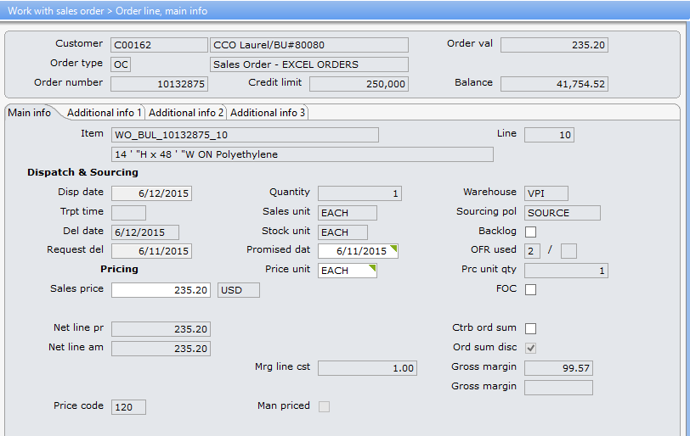

**Disp date**

Indicates the date that the goods will be dispatched to your customer.

Note: This value can be changed.

* If a message is displayed indicating that the dispatch date is invalid, the reason can be one of the following: The date format is not correct (as defined in the Language table).
* The entered date is not a work day (as defined in the Calendar file)
* The date has not been updated in the Calendar file.

**Del date**

Shows the date that the sales order line will be delivered at the customer site.

This value is calculated as:

*Dispatch date + number of days in transport time*

**Request del**

A value is only entered in this field if your customer requests that goods be delivered on a particular date. If a value is not entered then the requested date will be calculated as follows:

* **Dispatch date** + number days in the [Customer transport time table](http://192.168.0.56:18200/help/ntopic/net.ibs.doc.user.dft_locale_en/enterprisehelp/dis/DMR024.htm).

Enter the customer's requested delivery date.

**Promised dat**

Enter the date when the order line was promised to be dispatched. The system automatically suggests the dispatch date when a new line is entered. **Note**: The date can only be changed if the order line status is equal to, or higher than, status 20 (order confirmation printed).

## Mining

Here is the actual data.



SELECT OHORNO, olline, ohdelt as "Dispatch Date", oldelt as "Disp date", oldlvd as "Del date",

olpddt as "Promised dat", olrdvd as "Requested Del"

FROM VT2662AFvp.SROORSHE sheader

left join VT2662AFvp.SROORSPL sline on sheader.ohorno = sline.olorno

WHERE ohorno = 10132875

## Design

The post date will added to the Design page with a pop up calendar to assist with entry. Format the page fields for best fit, i.e. the quantity field could be smaller if you need the room. Should be a correct date with it being a date in the future.

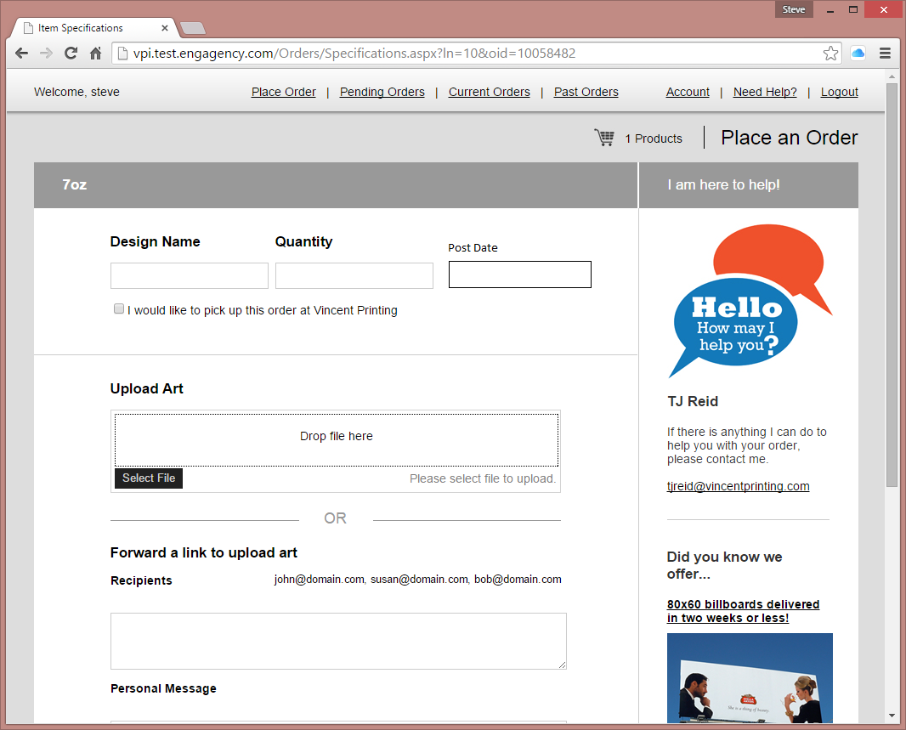

TJ has requested that you make the sql update call to add the date to the newly inserted line.

After successful insert of line.

update VT2662AFvp.SROORSPL set olrdvd = “<post date >”

WHERE olorno = 10058482 and olline = 10